* **BREAKING**



**Support our students with specialized**

**instruction and service!**

Uncommon Schools

**Apply**



**BOLD TYPES**

Red Sox 10, Braves 8, Final

**Bill Walczak returns to health**

**center roots**

August 26, 2015, 8:44 p.m.

**Bill Walczak** can’t get health care out of his blood.

Many Bostonians know Walczak (below) mainly as a candidate in the city’s crowded 2013 race for mayor. But most of his career was spent as CEO of Dorchester’s nonprofit **Codman Square Health Center**, which he cofounded in 1975. He left in 2012 to become president of **Carney Hospital**, but that gig soon ended due to what he calls a “philosophical disagreement” with Carney’s owner, **Steward Health Care System**, over the hospital’s future.

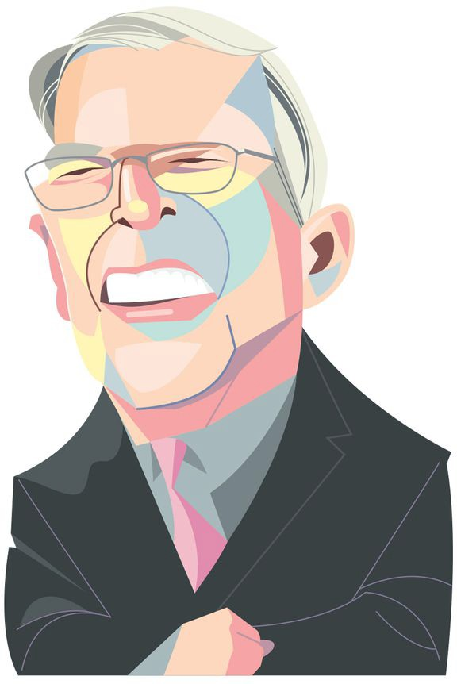

CHRIS MORRIS FOR THE BOSTON GLOBE

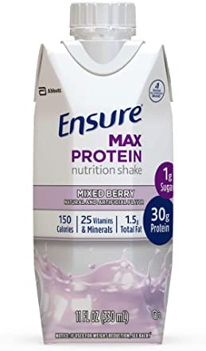

*30g protein and nutrients to support immune health*

10% off coupon

Ensure Max Protein Nutritional Shake with…

From there, Walczak bounced around a bit. He was a vice president at **Shawmut Design and Construction**. He ran for mayor. He was president of Boston’s **Lewis Family Foundation** and **Grand Circle Foundation**, a job he cut short to help his wife fight cancer.

Advertisement



Now Walczak is back to his roots: He’s the **South End Community Health Center’s** new CEO.

# Get Business Headlines in your inbox

[example@email.com](mailto:example@email.com)

**Sign Up**

The Globe's latest business headlines delivered every morning, Monday through Friday.

Enter Email

**BOSTON GLOBE VIDEO**

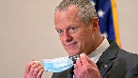

2:23

Baker announces ‘VaxM SHARE

“It feels right,” said Walczak, 61. “The health care system generally I feel very comfortable in.”

He’s also quite comfortable with his associate CEO, **Joel Abrams**, former president of **Dorchester House Multi-Service Center** . The two men founded **DotWell**, a Dorchester community organization.

They also have an Irish band called **Billy Joel** (get it?) that plays mostly at family parties. They’re sometimes joined by Walczak’s brother-in-law **Rob Atterbury**, and on those occasions, Walczak joked, “we change our name to ‘Billy Joel & Talent.’” — SACHA PFEIFFER

# Have a cold one with Big Papi before the game

If you somehow missed last year’s **Ice Bucket Challenge** craze, here’s one heck of a way to catch up: Have **Red Sox** slugger **David Ortiz** douse you at **Fenway Park** before a game against the **Yankees** next Monday.

It will cost you, of course — the top bid was $1,100 Wednesday evening in an online auction set to close at 8 p.m. Thursday — but proceeds benefit the **ALS Association**. The Sox are also auctioning off the ice-dumping services of six other players, including **Dustin Pedroia** and **Xander Bogaerts** .

Advertisement

High bidders will get cold showers on the field before the first pitch, then stay to watch the game. Each winner also receives a No. 3 jersey that players wore in spring training to honor **Pete Frates** , the former **Boston College** baseball star whose battle against **ALS** inspired the Ice Bucket Challenge. — CALLUM BORCHERS

# Full Contact lands Cambridge Savings Bank

**David Hasselhoff** continues to pay off for **Full Contact**.

The Boston ad agency, owned by **Marty Donohue** and **Tim Foley**, was just hired by **Cambridge Savings Bank** , thanks in part to the success of a campaign that featured the **Knight Rider** himself.

**Lisa Rodericks** , the bank’s chief marketing officer, said she was impressed by what Full Contact did to refresh two iconic New England brands: Framingham-based **Cumberland Farms** and the **Papa Gino’s** pizzeria chain in Dedham. For Cumby’s, cardboard cutouts of the Hoff hawking iced coffee became hot items as millennials stole them for their apartments. (The former **“Baywatch”** star also starred in TV ads, including one with him singing a new song, “Thirsty for Your Love.”)

Full Contact also used cardboard cutouts for Papa Gino’s as part of a campaign involving Patriots legend **Tedy Bruschi** .

Will Cambridge Savings join the cutout craze? It’s hard to say right now. The campaign is still in its formative stages and will probably be launched in early 2016. CEO **Wayne Patenaude** wants Rodericks, who came on board last winter, to modernize the 181-year-old bank’s image and draw younger customers. “The history of our bank is great,” Rodericks said, “but we need to refresh and become more relevant to a larger market.” — JON CHESTO

Advertisement

# Grantham honored with Carnegie award

**Jeremy Grantham** is known in investment circles as the cofounder and chief investment strategist at **Grantham, Mayo, Van Otterloo & Co.**, but his real passion is environmental protection.

Jeremy and **Hanne Grantham** are among the recipients of the 2015 **Carnegie Medal of Philanthropy** , given in recognition of their work through the **Grantham Foundation for the Protection of the Environment**.

The annual award, established in 2001 and announced this week, acknowledges individuals who embody the legacy of **Andrew Carnegie**, the 19th century steel magnate who donated $350 million.

“This is a great honor, but we are particularly excited because so little philanthropy goes to environmental causes,” said Jeremy Grantham.

Founded in 1997, the family’s foundation focuses on bringing attention to food shortages, climate change, and the use of US coal utility plants. As of January 2014, Jeremy Grantham was the fourth-largest individual benefactor in Boston.

— JESSICA GELLER

# Pizza, the next frontier for venture capital?

If you see a venture capitalist working in a pizza joint, there are two possibilities: Either this week’s stock market downturn is worse than you thought, or you’re looking at **John Burns**, the chief investment officer at **Breakaway** in Boston.

Burns not only led the venture firm’s investment in **Oath Craft Pizza** , a Nantucket startup with a second location in **South Station**, but stepped in as interim chief executive this year.

Advertisement

Needless to say, funding — and running — a pizza company is highly unusual for a VC. The venture game is usually about finding the next disruptive technology, not the tastiest pepperoni pie.

But Burns sees something in the vision of Oath founder **Doug Fineman** that has made him veer into the low-tech world of crispy thin crust and pecorino cheese. — CALLUM BORCHERS

Can’t keep a secret? E-mail us [at boldtypes@globe.com.](mailto:atboldtypes@globe.com)

Governor Charlie Baker announced residents who are fully vaccinated against COVID-19 will have the chance to win $1 million in a special Lottery sweepstakes. (Photo by Matt Stone/Boston Herald via AP)

**s ns’**

**rd**

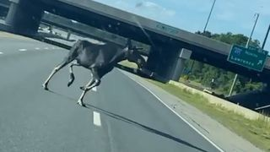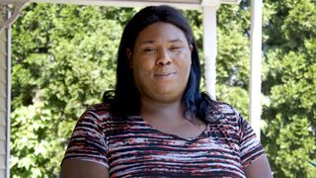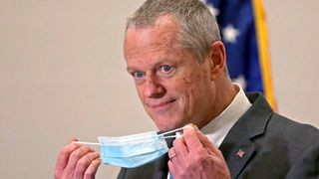

**Baker Moose What announce spotted Black ‘VaxMillio on liberation lottery Route 3 means program in to me:**

**Chelmsfo Athena**

**Vaughn**

**NOW PLAYING**

**MOST POPULAR ON BOSTONGLOBE.COM**

1. Baker announces ‘VaxMillions’ lottery program, offering $1 million cash prizes to boost vaccination rates
2. Message in a bottle, tossed into the sea in Rhode Island, found in Azores
3. Life sciences is poised to be Boston’s dominant industry. Has the area become the Silicon Valley of biotech?
4. The downside of ditching masks: the return of colds, flu
5. The case for prosecuting Donald Trump
6. How white supremacy weaponizes ignorance
7. A treasure map for an American tyrant
8. ‘Boo Boo’ the South Shore Bear captured on video roaming in Duxbury
9. Paul Pierce to launch ‘Truth’ marijuana brand in Massachusetts
10. 5 things to know about the VaxMillions lottery sweepstakes in Mass.



**VIEWS FROM OUR COLUMNISTS**

**YVONNE ABRAHAM**

Energy efficiency is a low- hanging fruit to combat climate change. So why can’t everyone get access to it?

**KEVIN CULLEN**

Bill Bratton on American policing and the challenge facing the Boston Police Department

**THOMAS FARRAGHER**

A salute across the ages to an old squad leader

**SHIRLEY LEUNG**

A working mother’s manifesto: Pandemic provides a once-in-a- generation chance to course correct how we work

**JENEÉ OSTERHELDT**

Juneteenth and the meaning of Black liberation in Boston

**ADRIAN WALKER**

‘The best Boston movie no one’s ever seen’: ‘Blue Hill Avenue’ at 20

**Show comments**

**MORE ON GLOBE.COM**

**SPONSORED BY: PHILIP MORRIS INTERNATIONAL**

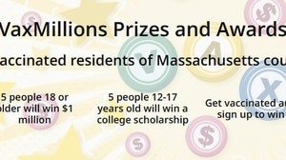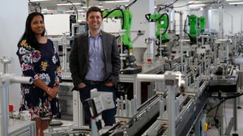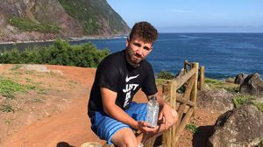

**Remote health care could be — and should be — here to stay**

In response to the pandemic, insurers expanded coverage for virtual health services. How long will it last?

**Baker announces ‘VaxMillions’ lottery program, offering $1 million cash prizes to boost vaccination rates**

State officials on Tuesday said residents who’re fully vaccinated against COVID-19 will have the chance to win $1 million in a special Lottery sweepstakes.

**INNOVATION ECONOMY**

**Life sciences is poised to be Boston’s dominant industry. Has the area become the Silicon Valley of biotech?**

Since December, you can find six major indications that Boston is the undisputed center of the life sciences industry, a place where ideas and products that change ― and save ― people’s lives around the world originate.

**RI NEWS**

**Message in a bottle, tossed into the sea in Rhode Island, found in Azores**

The note was written in 2018 by a 13- year-old who was visiting family in Rhode Island.

**The downside of ditching masks: the return of colds, flu** Since the state’s mask mandate was lifted, face coverings have started to come off — and stay off. But according to infectious diseases doctors, the return of facial freedom might come with some downsides, like a resurgence in cases of the common cold and the flu.

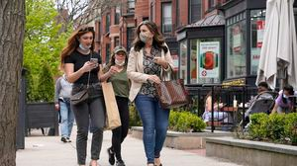

**The case for prosecuting Donald Trump**

Saving American democracy for the long run requires a clear condemnation of the Trump presidency. That means making clear that no one is above the law.

**OPINION**

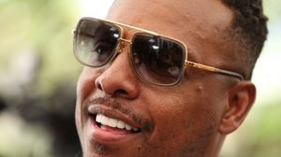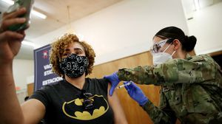

**How white supremacy weaponizes ignorance**

Racists have always understood that if they can censor what people learn, they can control what people believe.

**A treasure map for an American tyrant**

Donald Trump exposed weaknesses that a would-be dictator could exploit to end our democracy. It’s now up to lawmakers, voters, and public officials to prevent that from happening.

**Paul Pierce to launch ‘Truth’ marijuana brand in Massachusetts**

The legendary ex-Celtic says cannabis helped save his career after a traumatic stabbing in 2000.

**5 things to know about the VaxMillions lottery sweepstakes in Mass.**

Here are five things you should know about the VaxMillions program, which will make some lucky winners living proof that trusting the science really does pay.

**METRO SPORTS BUSINESS & TECH OPINION**

WELCOME, JOHN

**TODAY'S PAPER**

**Check out this week's**

**virtual events**

RSVP now

**LAWMAKERS STRIKE DEAL TO RESTORE PANDEMIC-ERA POLICIES, INCLUDING EVICTION PROTECTIONS, TO-GO COCKTAILS**

**MOST READ IN THIS SECTION**

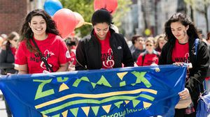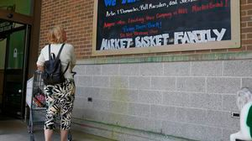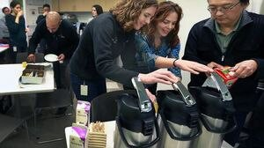

**INNOVATION ECONOMY**

**Life sciences is poised to be Boston’s dominant industry. Has the area become the Silicon Valley of biotech?**

**These Massachusetts organizations received donations from MacKenzie Scott**

**A power play? Steam plant owner aims to decarbonize downtown with huge building project**

**The saga of Demoulas’ Market Basket**

**A vast grown-up play space — from the folks behind Panera and Eastern Standard — is opening at Natick Mall**

**“We will not be broken:” Nurses strike in Worcester reaches 100 days**

**As contaminated water concerns grow, Massachusetts towns urge the state to stop spraying pesticides in their communities**

**INNOVATION ECONOMY**

**Everyday virtual reality? Developers at this MIT event had some ideas for the future**

**Hate your office coffee? These companies want to make it better**

**FOLLOW US**

**SUBSCRIBE NOW MY ACCOUNT CONTACT MORE**



Digital Access Home Delivery Gift Subscriptions

Log In

Manage My Account Customer Service

Help & FAQs Globe Newsroom Advertise

Newsletters / View The EPaper /

Order Back Issues / News In Education / Search The Archives / Privacy Policy / Terms Of Service / Terms Of Purchase / Work At Boston Globe Media /

Do Not Sell My Personal Information

©2021 Boston Globe Media Partners, LLC